**

SCHOOL OF ELECTRICAL AND ELECTRONIC ENGINEERING

Bachelor of Engineering (Hons) BE in Elect/Cont/Comm/Comp Eng

Program Code: (DT021A)

<YEAR 4>

Name of Module: ([Solid State Electronics, ELTR2603](https://brightspace.tudublin.ie/d2l/home/179100))

**TU Dublin – Grangegorman**

# Lab 1: Lattice Planes and Miller Indices

Student Name: _Talha Tallat, D18124645 ____________________________

Academic Lecturer:  _Yuliya Semenova__________________________________

Submission Date: _14th October 2021_________________________________

Table of Contents

Lab 1: Lattice Planes and Miller Indices 1

1. Laboratory Objectives 3

2. Laboratory Tasks 3

3. Results 4

3.1. Identify the planes 4

3.2. Short Questions 5

3.3. Open-Ended Questions 6

4. References 10

Table of Figures

Figure 1 - Game allows a user to drag each index to the box below the correct plane in order to identify the planes [1] 4

Figure 2 – List of 6 short questions answered [1] 6

Figure 3 - lattice planes {100}, {110} and {111} type planes in a cubic system 7

Figure 4 - (-121) planes 8

Figure 5 - body centered cubic lattice 9

# Laboratory Objectives

The objectives of this lab were to gain the necessary background in the method used to describe planes of atoms in a crystalline material.

On completion of this laboratory exercise student must understand the concept of a lattice plane and to be able to determine the Miller indices of a plane from its intercepts with the edges of the unit cell and to be able to visualise and draw a plane when given its Miller indices.

Making sure that student is aware of how knowledge of lattice planes and their Miller indices can help to understand other concepts in materials science.

# Laboratory Tasks

The lab tasks were to use the on-line teaching and learning package (© University of Cambridge) at <http://www.doitpoms.ac.uk/tlplib/miller_indices/index.php>

* To revise the following topics:
* How to index a lattice plane
* Parallel lattice planes
* How to draw a lattice plane
* Bracket conversions
* Examples of lattice planes
* Practice drawing lattice planes using the corresponding animation.
* Complete answers to the game (Identify the planes) and answer both “quick” and “open-ended” questions in the “QUESTIONS” section online.
* Document all your answers for your lab report (you will need to sketch the planes presented in the “Game” animation. Note the task will change if you re-load the page).

# Results

## Identify the planes

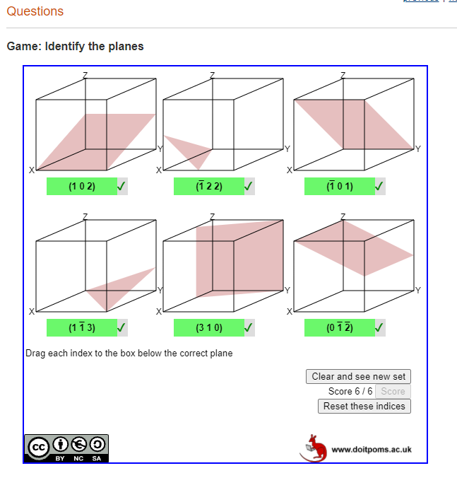

Figure 1 - Game allows a user to drag each index to the box below the correct plane in order to identify the planes [1]

## Short Questions

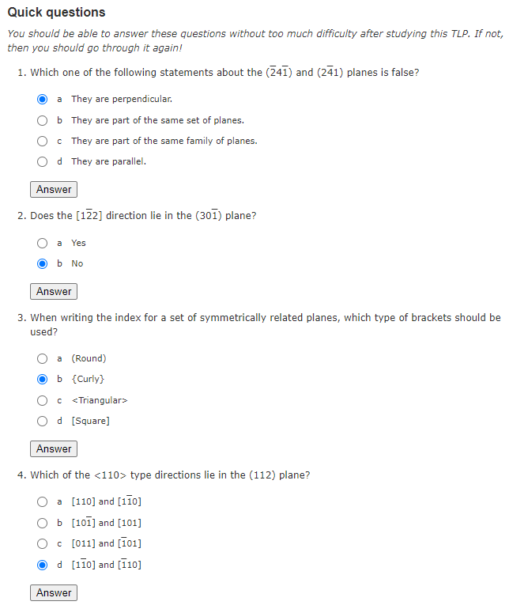

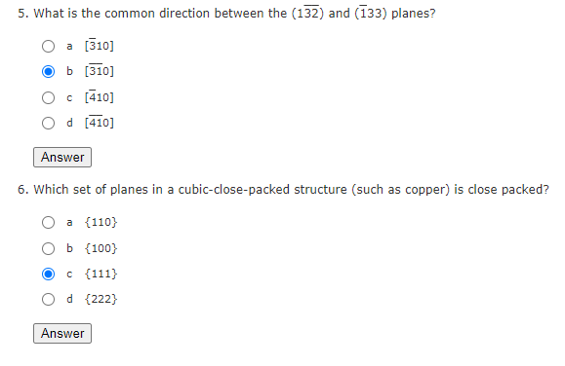

Figure 2 – List of 6 short questions answered [1]

## Open-Ended Questions

**Question 7**: Practice sketching some lattice planes. Make sure you can draw the {100}, {110} and {111} type planes in a cubic system.

Figure 3 - lattice planes {100}, {110} and {111} type planes in a cubic system

**Question 8**: Draw the trace of all the (-121) planes intersecting a block 2 × 2 × 2 block of orthorhombic (a ≠ b ≠ c, α = β = γ = 90°) unit cells.

Figure 4 - (-121) planes

**Question 9**: Sketch the arrangement of the lattice points on a {111} type plane in a face centred cubic lattice. Do the same for a {110} type plane in a body centred cubic lattice. Compare your drawings. Why do you think the {110} type planes are often described as the "most close packed" planes in bcc?

Figure 5 - body centered cubic lattice

# References

**[1]** "DoITPoMS - TLP Library Lattice Planes and Miller Indices", Doitpoms.ac.uk, 2021. [Online]. Available: http://www.doitpoms.ac.uk/tlplib/miller_indices/index.php. [Accessed: 14- Oct- 2021]